1a. 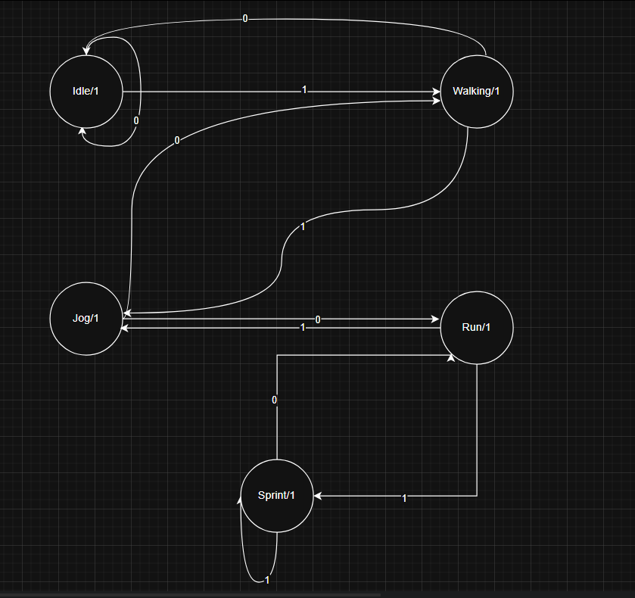
1b.
Current State | Next State  X=0 | Next State  X=1 | Output  X=0 | Output  X=1
Idle | Idle | Walking | 1 | 1
Walking | Idle | Jogging | 1 | 1
Jogging | Walk | Run | 1 | 1
Run | Jog | Sprint | 1 | 1
Spring | Run | Sprint | 1 | 1

2a. 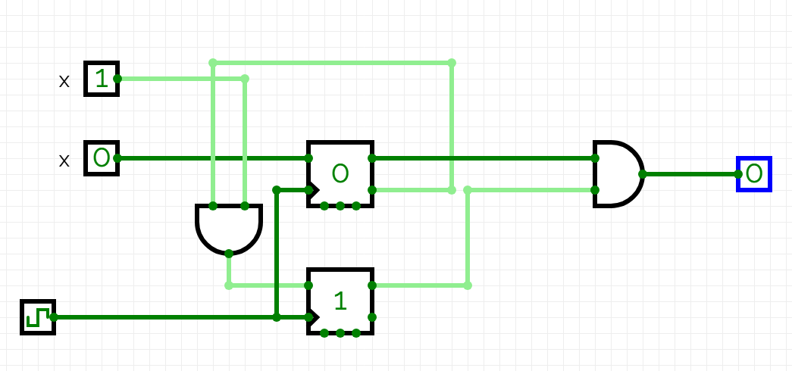
C. Here’s the Full Code Block
// State Encoding (Binary encoding used here)
parameter S0 = 2'b00;
parameter S1 = 2'b01;
parameter S2 = 2'b10;
parameter S3= 2'b11;

// State Registers
reg [1:0] current_state;
reg [1:0] next_state;

// 1. Sequential Block: State Register Update
// Handles reset (asynchronous, active-low) and clock edge transitions
always @(posedge clk or negedge rst_n) begin
if (!rst_n) begin
current_state <= S0;
end else begin
current_state <= next_state;
end
end

// 2. Combinational Block: Next State and Output Logic
// Determines the next state and output based on CURRENT state and INPUT
always @(*) begin
// Defaults: remain in current state, output low
next_state = current_state;
out = 1'b0;

case (current_state)
S0_RESET: begin
if (in == 1'b1) begin
next_state = S1;
end else begin
next_state = S0_RESET; // Stay in RESET on input 0
end
end

S1: begin
if (in == 1'b1) begin
next_state = S2;
end else begin
next_state = S0; // Reset on input 0
end
end

S2: begin
if (in == 1'b0) begin
next_state = S3;
end else begin
next_state = S2; // Stay in S2 on another 1
end
end

S3: begin
if (in == 1'b1) begin
next_state = S1; // Completed 1101! Move towards next sequence
out = 1'b1; // Output high for one clock cycle
end else begin
next_state = S0; // Sequence broken
end
end

default: begin
next_state = S0;
out = 1'b0;
end
endcase
end

endmodule

